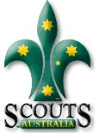
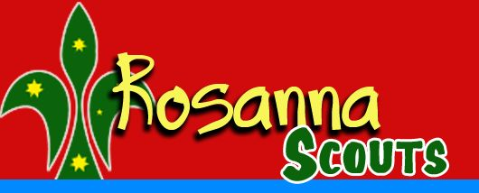

Rosanna Cubs & Scouts –
Northcote RSL
Tuesday 17th April

On Tuesday, the 17th, we’re going to meet at Northcote RSL to learn about “Their Service – Our Heritage” as part of earning the Heritage Badge.
Note… NO SCOUTS on Wednesday the 18th!

Details:
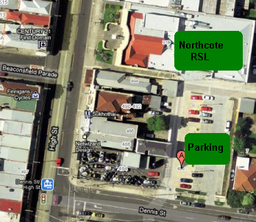
- Meet at Northcote RSL, 496 High St, Northcote – enter carpark off Dennis St (see map) at 7:10 pm sharp.
- Pickup from the RSL at the conclusion between 8:15 & 8:30pm.
Cubs and Scouts will be learning about the service of our Service men and women….. and if we’re lucky, they might even give us some snacks! For those who also attend Anzac Day Services, these will complete their Heritage Badge requirements. For others, this will cover half the badge and we can sort out the requirements for the rest.
Melway Ref: 30 D7

See you there – don’t miss it!


Akela & Michelle
9434 7594
0411 121 495
akela@rosannacubs.org
michelle@rosanascouts.org

